Blockchain and Cryptocurrencies:

What does it do?

Blockchain has had a steady rise in popularity over the past decade with the phenomenal success of the cryptocurrencies Bitcoin and Ether (on the Ethereum blockchain). The idea for the blockchain system has a long history, an early predecessor was proposed in a dissertation by David Chaum in 1982 (Sherman, Javani and Golaszewski, 2021). In the dissertation Chaum proposed a system of vaults which would contain a signature and data of every transaction in the network, when records are added to the vaults are then validated by other nodes in the network forming a consensus on the change (Costea, 2021). In early January 2009, the blockchain based cryptocurrency Bitcoin was launched by an unknown entity under the pseudonym Satoshi Nakamoto. While not the first proposed digital currency, Bitcoin is by far the most successful use case for blockchain technology (History of blockchain, 2021) and is the most successful cryptocurrency with more than double the market cap of the next most popular cryptocurrency, Ethereum (Cryptocurrency Prices, Charts and Market Capitalizations | CoinMarketCap, 2021).

The blockchain is a form of database consisting of blocks that contain information regarding transactions, a unique identifier for the block known as a hash and the hash of the preceding block (CONWAY, 2021). With the creation of each block a chain is formed, each block referring to its predecessor and being referred to by its eventual successor. In blockchain terms, a transaction refers to any action triggered by a participant. When a transaction is made, it is broadcast to all participants in the network for validation, once validated the transaction is added to the current block, eventually that block is then validated by every node in the system and added to the blockchain and work on a new block begins (Miraz and Ali, 2021). This is all made possible with peer-to-peer (P2P) communication. This P2P network also brings a level of security as each node working on the blockchain must build trust with other nodes, any suspicious activity from one node will lower its trust levels and bring further scrutiny ensuring the integrity of the blockchain (Al-Rakhami and Al-Mashari, 2021).

Blockchain visualized:

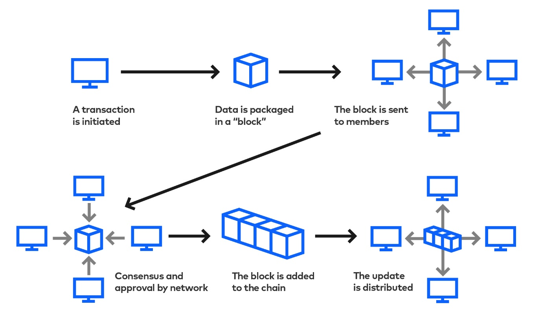

(Image from <https://www.slalom.com/insights/how-blockchain-will-disrupt-your-industry>)

Currently the main appeal of the blockchain is its security features and decentralized platform, the secure nature of the blockchain has allowed over seven thousand (Wanguba, 2021) cryptocurrencies to be established. Some are clones of Bitcoin; some bring their own unique features and others are completely useless. The original intent for Bitcoin was to “allow online payments to be sent directly from one party to another without going through a financial institution” (Nakamoto, 2021), a form of digital cash. Although originally intended to be digital currency, Bitcoin and all other cryptocurrencies have been labelled as assets by the ATO and the IRS (Tax treatment of crypto-currencies in Australia - specifically bitcoin, 2021) (Frequently Asked Questions on Virtual Currency Transactions | Internal Revenue Service, 2021). Cryptocurrency is not widely accepted, thus making it hard to use as a true currency, instead crypto is bought and sold in large volumes as a speculative investment (Cryptocurrencies and ICOs - Moneysmart.gov.au, 2021). Crypto may be mined through providing computing power for a network or more commonly, bought and sold on exchanges similar to the stock market (Cryptocurrencies | Explainer | Education, 2021). Another recent development in the world of blockchain is the NFT (No fungible token), these are unique digital artworks where ownership can be bought and the tokens may be exchanged with others. The majority of NFTs are part of the Ethereum blockchain (Clark, 2021).

Blockchain technology can be expanded beyond internet currencies/assets. One such area that may benefit from the use of blockchain technology would be supply chain monitoring, a blockchain system may be used to track the location and other data of an item through a chain of trusted entities. The process would be similar to how a transaction is traced when a cryptocurrency is exchanged. By combining blockchain and internet of things technology, every party in the chain of supply can provide trustworthy data in real time. In order for this to be implemented there will need to be some improvements to blockchain, specifically finding a way to decrease the computational power required whilst maintaining security, improving the way consensus between nodes is determined and making the technology more accessible to users (Al-Rakhami and Al-Mashari, 2021).

What is the impact?

Blockchain has the potential to impact financial technology (FinTech) substantially by increasing the volume of monetary transfers between institutions and reducing the associated costs. The decentralized nature of blockchain has allowed for the public to instantly transfer wealth without being reliant on the financial institutions or physical cash. Blockchain has given rise to a new group of lenders that allow people to use their cryptocurrency holdings as leverage loans of all sizes. SALT is an example of a company that provides crypto backed loans from $5,000 to up into the millions without credit checks, simply owning enough crypto to use as collateral if enough for them to issue a loan (Personal Loan, 2021). The lack of credit checking can bring risks to the loan provider and an overzealous borrower but it does bring a level of freedom to people with no credit history.

Another potential impact of blockchain technology is in the healthcare sector. As blockchain is a decentralized record keeping system, the medical data of patients may be encrypted and stored in the chain, with updates being appended with each visit. Having medical data accessible in one secure chain would improve communication between visits to medical institutions as there should be no breakdown breaks in the patient history dating back to the original entry on the chain (Spilka, 2021). This will help people that are unfortunate enough to face a myriad of medical issues in their lifetimes.

Blockchain and cryptocurrency are already having an impact on businesses in the FinTech sector by allowing anyone to transfer large sums of wealth quickly, securely, anonymously and cheaply without the assistance of larger financial institutions. Businesses and services based around cryptocurrency trading and lending have taken off over the last five years and will continue to grow as more money is pumped into the market, this will create more jobs. Bitcoin is yet to be adopted as a currency in most of the world but it has become the second nation currency of one small Central American country El Salvador, although the results of this adoption are yet to be determined (El Salvador Becomes First Country to Adopt Bitcoin as National Currency, 2021).

How will this affect you?

So far, the impact of cryptocurrency and blockchain has been very minor for myself. In late 2020 I gradually moved around 10% of my savings into Bitcoin, Ethereum and Ripple (XRP) to test the waters. Not long after I’d established my crypto holdings, the market suffered a bit of a downturn and I held on until late September 2021 when my crypto neared the breakeven point for my initial investment. My monetary losses were minor but slightly embarrassing. I have no intention of getting back into crypto for the foreseeable future as I believe the lack of regulation to be rather dangerous, the fluctuations are immense, it seems easily manipulated by large holders (Tesla and Bitcoin for example) and the amount of predatory spinoff coins (FRANKENFIELD, 2021) delegitimize the entire market in my opinion. I firmly believe that cryptocurrency is not as decentralized as originally intended and that it has turned into a get rich quick scheme and another way for the ultra-wealthy to avoid taxation.

The majority of my friends possess cryptocurrency, some with a large portion of their savings invested, I hope that the technology continues to improve and to garner interest as a legitimate currency rather than a speculative asset. My family does not currently hold any crypto but in the future their superfunds may begin purchasing mainstream currencies. I believe that blockchain as a database for supply chains will have a greater impact on everyone through improving business processes and passing on lowered costs with higher quality products.

In the distant future I hope that blockchain and cryptocurrency matures and becomes a much more widespread and consumer friendly service. The scarcity of Bitcoin has some interesting implications as a potentially deflationary asset and I’m interested to see how this plays out, it is rather discouraging seeing the purchasing power of my fiat currency decrease over time. Although I don’t hold any currently, there is niche bar outside the QVB in Sydney that accepts payment in Bitcoin and I’d love to try spending some.

References:

<https://arxiv.org/ftp/arxiv/papers/1810/1810.06130.pdf>

Sherman, A., Javani, F. and Golaszewski, E., 2021. [online] Arxiv.org. Available at: <https://arxiv.org/ftp/arxiv/papers/1810/1810.06130.pdf> [Accessed 10 October 2021].

<https://dt.gl/david-chaums-vault-system-the-worlds-first-blockchain/>

Costea, V., 2021. *dt.gl - David Chaum's Vault System: The World's First Blockchain*. [online] Decentralize.Today. Available at: <https://dt.gl/david-chaums-vault-system-the-worlds-first-blockchain/> [Accessed 10 October 2021].

<https://www.icaew.com/technical/technology/blockchain/blockchain-articles/what-is-blockchain/history>

Icaew.com. 2021. *History of blockchain*. [online] Available at: <https://www.icaew.com/technical/technology/blockchain/blockchain-articles/what-is-blockchain/history> [Accessed 10 October 2021].

<https://coinmarketcap.com/>

CoinMarketCap. 2021. *Cryptocurrency Prices, Charts And Market Capitalizations | CoinMarketCap*. [online] Available at: <https://coinmarketcap.com/> [Accessed 10 October 2021].

<https://www.investopedia.com/terms/b/blockchain.asp>

CONWAY, L., 2021. *Blockchain Explained*. [online] Investopedia. Available at: <https://www.investopedia.com/terms/b/blockchain.asp> [Accessed 10 October 2021].

<https://arxiv.org/abs/1801.03528>

Miraz, M. and Ali, M., 2021. [online] Arxiv.org. Available at: <https://arxiv.org/ftp/arxiv/papers/1801/1801.03528.pdf> [Accessed 10 October 2021].

<https://www.mdpi.com/1424-8220/21/5/1759/pdf>

Al-Rakhami, M. and Al-Mashari, M., 2021. [online] Mdpi.com. Available at: <https://www.mdpi.com/1424-8220/21/5/1759/pdf> [Accessed 10 October 2021].

<https://e-cryptonews.com/how-many-cryptocurrencies-are-there-in-2021/#Main_Types_of_Cryptocurrencies>

Wanguba, J., 2021. *How Many Cryptocurrencies Are There In 2021? - E-Crypto News*. [online] E-Crypto News. Available at: <https://e-cryptonews.com/how-many-cryptocurrencies-are-there-in-2021/#Main_Types_of_Cryptocurrencies> [Accessed 10 October 2021].

<https://bitcoin.org/bitcoin.pdf>

Nakamoto, S., 2021. [online] Bitcoin.org. Available at: <https://bitcoin.org/bitcoin.pdf> [Accessed 11 October 2021].

<https://www.ato.gov.au/general/gen/tax-treatment-of-crypto-currencies-in-australia---specifically-bitcoin/>

Ato.gov.au. 2021. *Tax treatment of crypto-currencies in Australia - specifically bitcoin*. [online] Available at: <https://www.ato.gov.au/general/gen/tax-treatment-of-crypto-currencies-in-australia---specifically-bitcoin/> [Accessed 11 October 2021].

<https://www.irs.gov/individuals/international-taxpayers/frequently-asked-questions-on-virtual-currency-transactions>

Irs.gov. 2021. *Frequently Asked Questions on Virtual Currency Transactions | Internal Revenue Service*. [online] Available at: <https://www.irs.gov/individuals/international-taxpayers/frequently-asked-questions-on-virtual-currency-transactions> [Accessed 11 October 2021].

<https://moneysmart.gov.au/investment-warnings/cryptocurrencies-and-icos>

Moneysmart.gov.au. 2021. *Cryptocurrencies and ICOs - Moneysmart.gov.au*. [online] Available at: <https://moneysmart.gov.au/investment-warnings/cryptocurrencies-and-icos> [Accessed 11 October 2021].

<https://www.rba.gov.au/education/resources/explainers/cryptocurrencies.html>

Reserve Bank of Australia. 2021. *Cryptocurrencies | Explainer | Education*. [online] Available at: <https://www.rba.gov.au/education/resources/explainers/cryptocurrencies.html> [Accessed 11 October 2021].

<https://www.theverge.com/22310188/nft-explainer-what-is-blockchain-crypto-art-faq>

Clark, M., 2021. *People are spending millions on NFTs. What? Why?*. [online] The Verge. Available at: <https://www.theverge.com/22310188/nft-explainer-what-is-blockchain-crypto-art-faq> [Accessed 11 October 2021].

<https://www.mdpi.com/1424-8220/21/5/1759/htm>

Al-Rakhami, M. and Al-Mashari, M., 2021. *A Blockchain-Based Trust Model for the Internet of Things Supply Chain Management*. [online] MDPI. Available at: <https://www.mdpi.com/1424-8220/21/5/1759/htm> [Accessed 11 October 2021].

<https://saltlending.com/personal-loan/>

SALT Lending | USD or Stablecoin Crypto & Blockchain Loans. 2021. *Personal Loan*. [online] Available at: <https://saltlending.com/personal-loan/> [Accessed 11 October 2021].

<https://www.nasdaq.com/articles/how-blockchain-will-change-the-way-we-work-play-and-stay-healthy-in-the-future-2021-08-26>

Spilka, D., 2021. *How Blockchain Will Change the Way We Work, Play and Stay Healthy in the Future*. [online] NASDAQ. Available at: <https://www.nasdaq.com/articles/how-blockchain-will-change-the-way-we-work-play-and-stay-healthy-in-the-future-2021-08-26> [Accessed 11 October 2021].

<https://www.wsj.com/articles/bitcoin-comes-to-el-salvador-first-country-to-adopt-crypto-as-national-currency-11631005200>

WSJ. 2021. *El Salvador Becomes First Country to Adopt Bitcoin as National Currency*. [online] Available at: <https://www.wsj.com/articles/bitcoin-comes-to-el-salvador-first-country-to-adopt-crypto-as-national-currency-11631005200> [Accessed 11 October 2021].

<https://www.investopedia.com/terms/s/shitcoin.asp>

FRANKENFIELD, J., 2021. *What Is Shitcoin?*. [online] Investopedia. Available at: <https://www.investopedia.com/terms/s/shitcoin.asp> [Accessed 12 October 2021].